Software Requirements Specification

for

Movieteca

Prepared by:
Preda Radu Alexandru | CEN 3.3A
Radulescu Alexandru | CEN 3.3A
Simon Jozsef-Gabriel | CEN 3.3A
Sacuianu Ionut Alexandru | CEN 3.3A

Instructor: | Cosmin Stoica Spahiu
Course: | Project II – Use of Databases
Date: | 08.03.2020

Table of Contents

TABLE OF CONTENTS II

1. INTRODUCTION 1

1.1 Document Purpose 1

1.2 Product Scope 1

1.3 Definitions, Acronyms and Abbreviations 1

1.4 References and Acknowledgments 4

2. OVERALL DESCRIPTION 5

2.1 Product Functionality 5

2.2 End Users and Characteristics 6

2.3 System Stakeholders 6

2.4 Operating Environment 7

3. SPECIFIC REQUIREMENTS 8

3.1 User Interface 8

3.2 Functional Requirements 11

4. NON-FUNCTIONAL REQUIREMENTS 15

4.1 Software Quality Attributes 15

5. OTHER REQUIREMENTS 17

5.1 Security requirements 17

5.2 Safety requirements

17

Introduction

Document Purpose

The purpose of this document is to present a detailed description of the functionalities which will be implemented in the development of the movie rental web application called “Movieteca”. Using this documentation, a user can find out the essential features of the application, as well as the purpose of the application, the interface, how it works and the constraints under which it must operate. This document is intended for users and also for potential developers.

Product Scope

This project idea is to implement an online movie rental system, where the customers can find different movies to rent or buy from different providers, depending on the stock. The costumers will be able to ask questions through a in-app chat functionality, through which, he will be able to talk with the administrator or with the provider, which will also be able to talk with customers in case of different changes or emergencies. We want to implement all the application in an easy to use manner, such that all the customers and providers to access the features fast and easily.

As you can see, there will be 2 roles available, costumer and provider. The costumer will be able to access the features of the application for buying/renting movies which will be added to a shopping cart, make reviews to different movies and providers, communicate with providers or with the administrator, but he will not be able to add movies for rent or sell, that is a functionality only a provider will be able to do. The administrator will accept or decline different requests of adding movies for rent/sell, as well as, keeping an eye on the reviews and approve them or not. All of them will be able to register using a username and a password.

So, the main scope of this project is to implement an easy to use web application that will represent an online movie rental system. All the movies, informations and other data will be added to a database, which will be handled by the administrator.

Definitions, Acronyms and Abbreviations

GUI – Graphical User Interface.

HTML – Hyper Text Markup Language.

HTTP – Hyper Text Transfer Protocol.

iMDb - Internet Movie Database.

QA – Quality Assurance.

RAM - Random Access Memory

SSMS – SQL Server Management Studio.

Client – a computer process that requests a service from another computer and accepts the server's responses.

Data – are individual units of information. A data describes a single quality or quantity of some object or phenomenon. In analytical processes, data are represented by variables.

Database – a collection of related data stored in one or more computerized files in a manner that can be accessed by users or computer programs via a database management system.

Database management system – an integrated set of computer programs that provide the capabilities needed to establish, modify, make available, and maintain the integrity of a database.

Dataset – is a collection of data. In the case of tabular data, a data set corresponds to one or more database tables, where every column of a table represents a particular variable, and each row corresponds to a given record of the data set in question. The data set lists values for each of the variables, such as height and weight of an object, for each member of the data set. Each value is known as a datum. Data sets can also consist of a collection of documents or files.

Feature – a notable property of a device or software application.

Functionality – the tasks that a computer, software program, or piece of electronic equipment is able to do.

Graphical User Interface (GUI) – is a form of user interface that allows users to interact with electronic devices through graphical icons and audio indicator such as primary notation, instead of text-based user interfaces, typed command labels or text navigation. The actions in a GUI are usually performed through direct manipulation of the graphical elements.

Interface – in computing, is a shared boundary across which two or more separate components of a computer system exchange information. The exchange can be between software, computer hardware, peripheral devices, humans, and combinations of these. Some computer hardware devices, such as a touchscreen, can both send and receive data through the interface, while others such as a mouse or microphone may only provide an interface to send data to a given system.

Java – 1.is a set of computer software and specifications developed by James Gosling at Sun Microsystems, which was later acquired by the Oracle Corporation, that provides a system for developing application software and deploying it in a cross-platform computing environment. 2. is a general-purpose programming language that is class-based, object-oriented, and designed to have as few implementation dependencies as possible. It is intended to let application developers write once, run anywhere (WORA), meaning that compiled Java code can run on all platforms that support Java without the need for recompilation.

Performance requirement – a system/software system requirement specifying a performance characteristic that a system/software system or system/software component must possess; for example, speed, accuracy, and frequency.

Processor – also called central processing unit (CPU), or central processor or main processor, is the electronic circuitry within a computer that executes instructions that make up a computer program. The CPU performs basic arithmetic, logic, controlling, and input/output (I/O) operations specified by the instructions.

Quality Assurance – is a way of preventing mistakes and defects in manufactured products and avoiding problems when delivering products or services to customers.

Random Access Memory – is a form of computer memory that can be read and changed in any order, typically used to store working data and machine code.

Server – a central computer (server) which provides services such as file storage, printing, and communications in a network computing system.

Software requirement – a software capability that must be met or possessed by a system or system component to satisfy a contract, standard, specification, or other formally imposed document.

SQL – stands for Structured Query Language. SQL is used to communicate with a database. SQL statements are used to perform tasks such as update data on a database, or retrieve data from a database.

SSMS – is an integrated environment for managing any SQL infrastructure, from SQL Server to Azure SQL Database. SSMS provides tools to configure, monitor, and administer instances of SQL Server and databases.

System – a composite of equipment, skills, and techniques capable of performing or supporting an operational role or both. A complete system includes all equipment, related facilities, material, software, services and personnel required for its operation and support to the degree that it can be considered a self-sufficient item in its intended operational environment.

System Requirement – a condition or capability that must be met or possessed by a system or system component to satisfy a condition or capability needed by a user to solve a problem.

Web Application – in computing, a web application or web app is a client–server computer program that the client (including the user interface and client-side logic) runs in a web browser.

References and Acknowledgments

General informations:

https://en.wikipedia.org/

IEEE 830-1998 template:

http://www.math.uaa.alaska.edu/~afkjm/cs401/IEEE830.pdf

Datasets for the database:

https://www.imdb.com/interfaces/

https://datasets.imdbws.com/

Overall Description

Product Functionality

This application will contain the following functionalities:
- Sign up or sign in the website;
- In the sign up section, select which type of role you want to have: customer or provider;
- The administration role will be given only by the owners of the website, which will create an account for them;
- If the provider will be chosen as a role, the website owners will ask for monthly payments for allowing them to publish different movies for rent/sell;
- If provider will be chosen as a role, the website owners will charge a tax for selling/renting their movies, which will be some percent from the price;
- See different movies informations like: title, iMDb rating, availability to buy or rent, storyline, most important cast members including actors, directors, writers, trailer, language, year, duration, rating and reviews, provider, genre;
- Rent or buy different movies according to their availability;
- Add different movies for renting or selling;
- Add movies to the cart;
- See limited informations about users;
- Chat with other users (depending on their roles);
- Approve reviews, movies listed for rent or sell, changes to different informations;
- User seeing and changing informations about themselves on the website;
- See different movies ordered by ratings, reviews, price, prizes won, year, playtime etc.
- See different movies according to their genre, provider, quality, price, cast, year, playtime etc.;
- See different top lists according to genres, providers, iMDb ratings, reviews;
- Contact the administrator for any problems like: cancellation of an order, problem in the account section, problem with the website, problem with the users (depending on their role);
- Return different movies that were rented, and if the user was late with the returning, calculation of the extra charge depending on the number of days the user was late;
- Attention a user that he will have to return the movie rented in 24 hours before the renting duration will terminate, otherwise he will be extra charged;
- Attention the user that he didn’t return a movie after the renting duration was over and he will have to pay an extra charge;
- Ban a user, from using the website, if he was late for more than 5 times he rented a movie, according to the average days he was late;
- Ban a user if he uses offensive words and indecent language in the reviews or chat;
- Report a user that used offensive words and indecent language in the reviews or chat;
- See other users reviews on the provider or movie;
- Give an appreciation sign to a review if it was helpful;
- Search different movies according to their title;
- User seeing the list of rented movies he has and also the remaining time he can keep them;
- User seeing different orders they made;
- Providers can manage the movies they added, manage the orders they have to make etc.;
- Add review to a movie and to a provider;
- Manage the list of top movies;
- Manage the movies added by the website owners for renting/selling;
- Manage the website.

End Users and Characteristics

This product will contain 2 types of users that will have very different characteristics. The first one is the customer, which will be able to use the website for renting and selling different movies added by different providers, which is another type of users and will be presented after, or added by the owners of the website. The customers is the one that will make orders on the website and will make the website popular by using it and giving it to other potential users, and from this point of view, is the most important.

The other type of user is the provider, which will be able to add movies for rent or sell on the website, by paying a monthly tax to the owners of the website, and a percent of the price of a movie they sold or rent. The providers have to be represented by a company which sells movies also, and they can use it as their website but only for selling and renting movies.

System Stakeholders
- Administrators team – which will be able to sign in for the website and make changes according to the owners. They will handle the movies published by the owners, approve different things, communicate problems and maintain the good looking of the website and the good functioning of the network. He will also handle the database for movies and different things.
- Development team – which will be leaded by the main architect and will be formed by the developers which will ensure the good functioning of the functionalities of the website.
- QA team – this team will handle tests for the website application in order to find bugs and errors which will be fixed by the developers in order to maintain the good functioning of the website.

Operating Environment

The selection of the hardware and software minimum specifications was made for the easy maintaining, capability to interface with other software and the efficient functioning of the application.
- OE-1: the website should operate on all modern web browsers.
- OE-2: 4GB RAM.
- OE-3: minimum Intel Pentium 4 processor.
- OE-4: internet connection.
- OE-5: Windows 7/8/10 as operating system.
- OE-6: Java 8.

Specific Requirements

User Interface
- Sign in page – on this page, the user will be able to log in to the website by writing the username and password. The role of the user will be selected after he logged in. If the necessary fields are not completed correctly (the data inserted is not found in the database), a message will pop up. Below is presented how the sign in page should look.
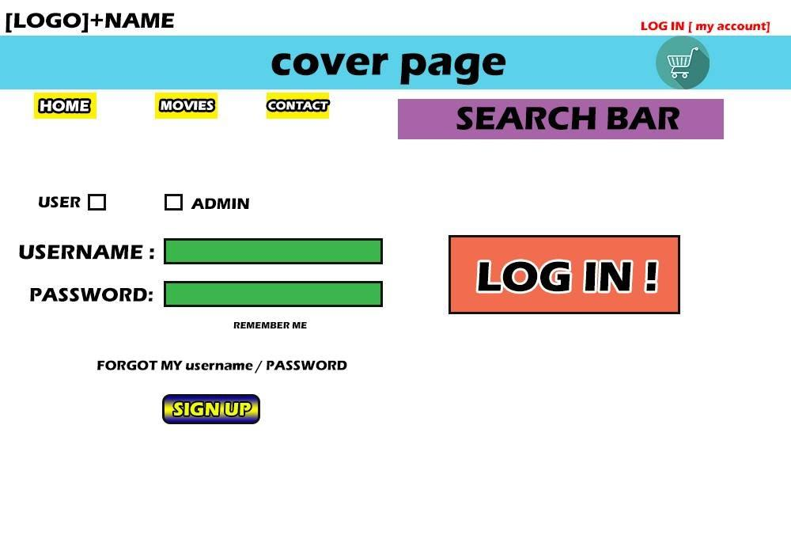

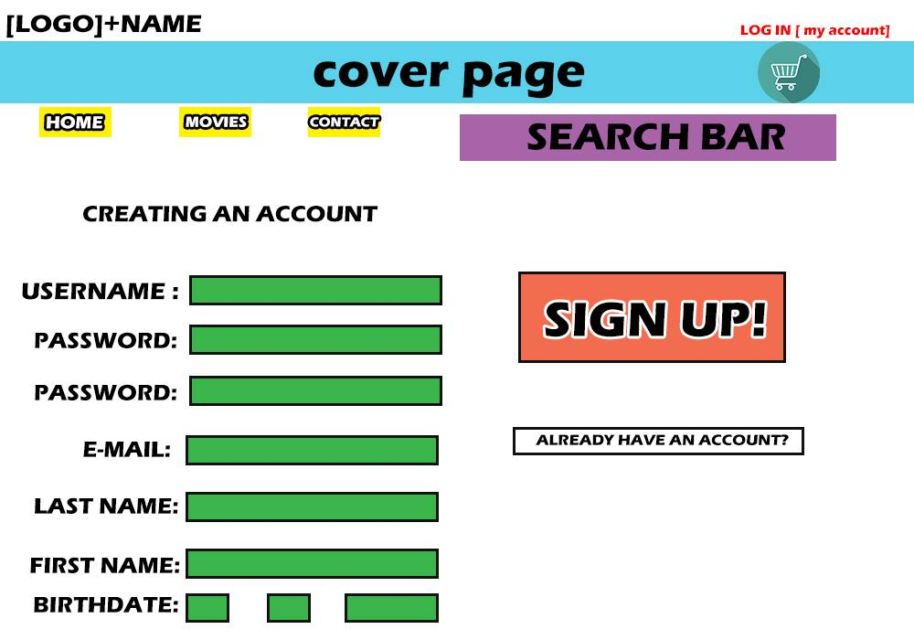
- Sign up (Register) page – in this page, the user will be able to create an account. Depending on the role selected, he will need to complete some fields regarding: username, password, e-mail, last name, first name, birthday etc. This are the general ones and will have to be completed if the customer role is selected. If the provider role will be selected, the user will have to complete additional or changed field like: name of the company, select a payment plan, the birthday will no longer be needed, and after that he will have to complete the necessary fields for payment: bank account, the billing address and name etc. Above is presented an image of how the sign up page would show up for the costumer.
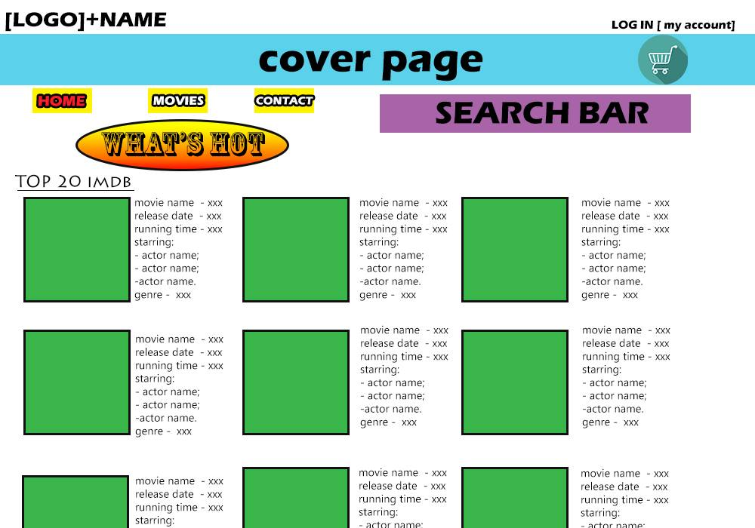
- Home page – here will be presented tops of movies according to: reviews, iMDb rating etc. Below is presented an image of how the home page will show up for all users.

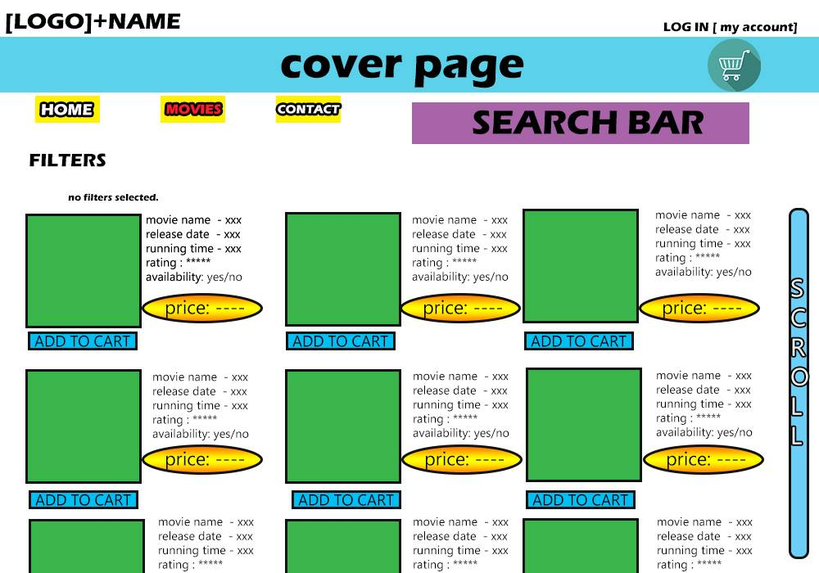
- Movies page – this page will present recently added movies, and the customer will be able to find movies based on title, genre, provider, price, iMDb rating, cast members of the movie, quality, year, availability for renting or buying etc. Also here, the customer can add a movie to his cart for renting or buying the movie. Above is presented how the movies page should look.
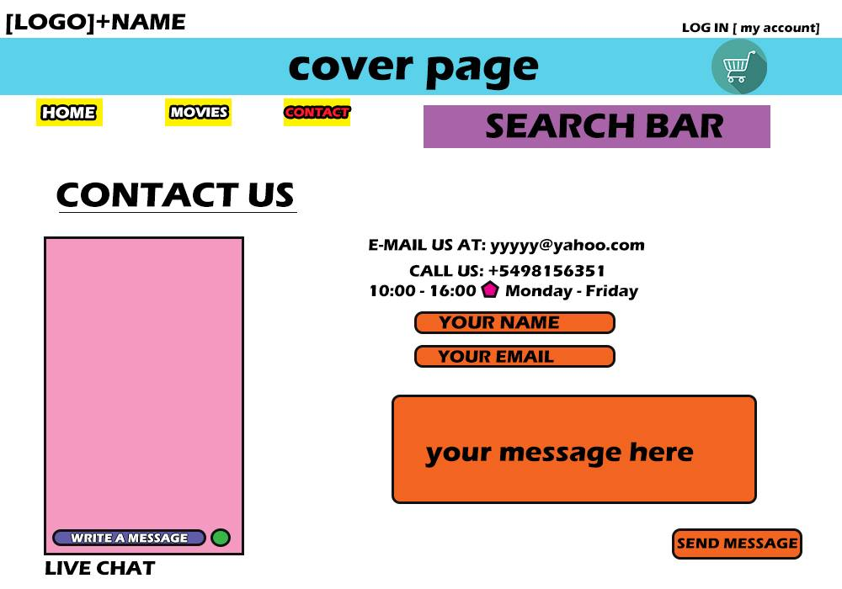
- Contact page – here the user will have a chat system where he can talk to other users regarding different problems. Here, the user will be also able to report another user for indecent language, offensive words, not returning back a movie in time, not receiving a movie rented or bought etc. Below is presented how the contact page should look.

- My account page – where, depending on the user, he can change different things, see informations about themselves or limited informations about other users (depending on the role), see their orders, modify orders, approve different things (administrator) etc. Below is presented how the my account page should look for a customer.

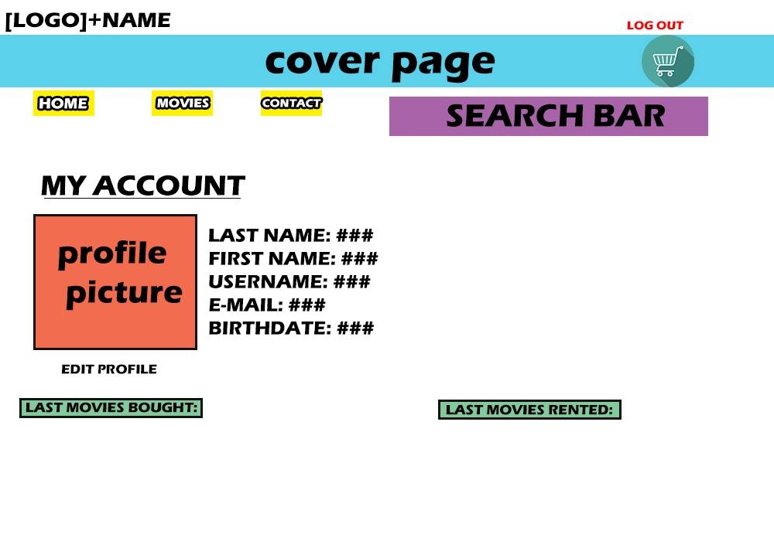
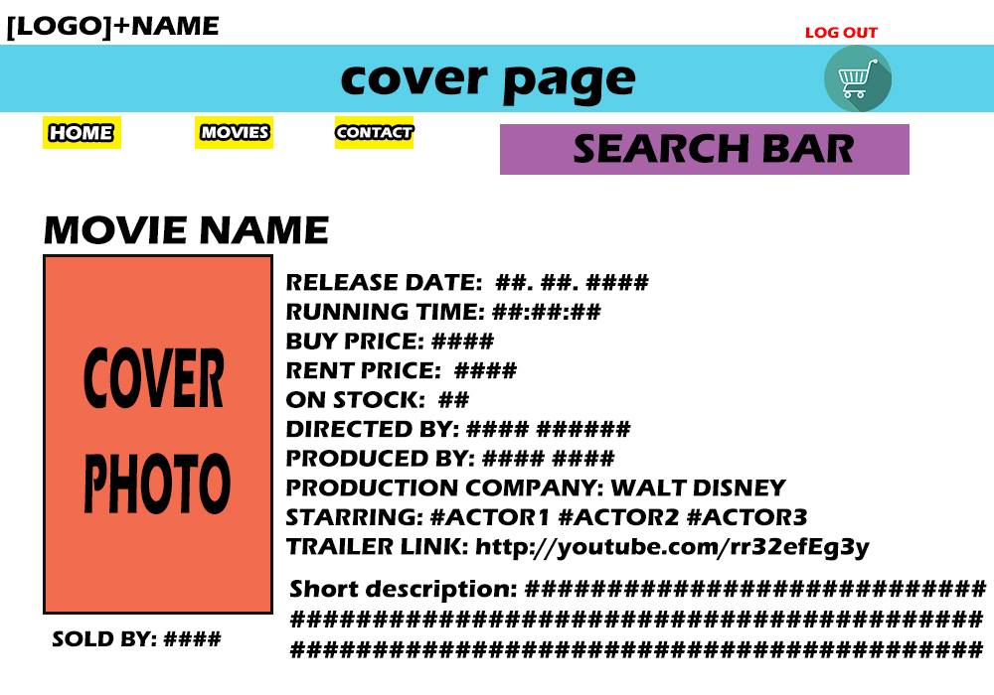
- Specific movie page – where a customer can see informations about different a movie they selected, add the movie to the cart, see a trailer of a movie, access a provider information, give reviews to the movie or to the provider etc. Here, also, a provider can change informations about a movie. Below is presented how a movie page should look for the customer.

- Specific provider page – the user can see informations about a provider selected and give it a review.
- Cart page – which will lead to payment page, and is where the costumer will se what they added to the cart.
- Payment page – here the customer will have to complete some fields for delivering the movie and payment bill.

Functional Requirements
- Login:
- In order to add movies to the cart for buying/renting them a customer user has to be logged in;
- In order to add movies for selling/renting them a provider user has to be logged in;
- In order to modify, approve and keep an eye on what is happening on the website application, the administrator has to log in;
- The user has to complete 2 fields in order to log in: username and password;
- If the password or username, does not coincide with those saved in the database, an error message will show up;
- There will be a method that will check the database and verify if the inserted texts from the fields are correct or not;
- If a user does not remember his username or password, he will have to press the “Forgot my username/password” button;
- If a user does not have an account, he will have to press the “Sign Up” button;
- Several methods will be implemented for this buttons, one for each;
- Register:
- The new user will have to choose first what type of role he wants to have: costumer or provider;
- The new user will have to complete several fields according to their role;
- A new costumer user will have to fill up the following fields: username, password, confirm password, e-mail, last name, first name, birthday, sex;
- A new provider user will have to fill up the following fields: username, password, confirm password, e-mail, company name, plan (dropdown box), bank account informations, billable address and name;
- If one of this is not correct, an error message will pop up explaining what is wrong;
- A method will verify if the inserted text from the fields are correct or not;
- A method will be implemented for the “Sign Up” button, which will add the inserted data by the user in the database;
- Searching movies:
- A costumer will be able to search for movies by inserting the title;
- Other options of searching will be: by year, by genre, by quality, by price, by iMDb rating, by number of reviews, by provider, by availability for renting or selling;
- The search function will be implemented by a method which will search in the database for the movie required taking into account what the costumer inserted in the field;
- For the function of searching by different other things than title, other methods will be implemented, one for each, that will take into account what the costumer chose;
- All this movies that will be searched will be showing up in alphabetical order, or in an order chosen by the costumer;
- Cart:
- There will be a button that will have to be pressed by the costumer in order to add a movie to the cart;
- The movie will show it’s availability for renting or buying, or even both;
- The button function will be implemented through a method that will add a movie to the cart database, which at first is empty;
- This action can be performed even in the specific movie page or in the movies page;
- Upload movie by providers:
- Each provider will have at my account page a section where they can publish movies for selling or renting them;
- In this section, the provider will have to complete some fields for availability to buy or sell, or both, the movie title, the movie price for each (rent and buy), and how many there are on the stock;
- After the fields were filled correctly, the request to publish button will be pressed;
- This button will send the request to the administrator, and it is going to be implemented in a method;
- The administrator will be the one who will approve the movie for publishing and by pressing the approve button, the movie will be added to available database, and the informations for this movie will be extracted from the dataset;
- For this actions, there will be implemented several methods that will send the request to publish to the administrator, and after the administrator will approve it, a method for the button which will publish the movie on the website;
- The movie informations will be extracted from a dataset using another method, in the moment the movie was published;
- If the administrator will not approve the movie, for different reasons, the disapprove button will be pressed;
- This last button will be implemented in a method which will send a message to the provider that the movie was not approve along side the reason;
- After the movie was published, the provider will be able to modify informations, but those modifications will have to be approved by the administrator;
- A method will be implemented for the modify button that will send the request to the administrator;
- Chat:
- The contact page will have a live chat box;
- This box will be implemented such that if any user will write a message, this will be added to the database of messages and immediately sent to the other user, so they will share the same informations (messages);
- The message will appear on his chat and he will be able to respond;
- My account:
- Here, the user will have several actions that he can do depending on the type of his role;
- The provider will be able to see the list of movies published, the requests approved and not approved, his profile informations, limited customers informations etc.;
- By pressing a button, he will be able to modify all these informations;
- The costumer will be able to see his informations, his rented/bought movies etc.;
- By pressing a button he will be able to modify the profile informations;
- The administrator will be able to see requests, reports, and he can approve requests, ban other users based on the reports, change the list of movies etc.;
- All these actions will be implemented in methods according to the necessary functionalities they need;
- This functionalities will be represented by buttons to the user;
- Log out:
- By pressing the “Log Out” button, the session will end and the user will no longer be able to make the actions mentioned above, until he log in again;
- This function will be implemented in a method which will end the session.

Non-functional Requirements

Software Quality Attributes
- The statement forming the body of an "if", "else if", "else", "while", "do ... while", or "for" statement shall always be enclosed in braces.
- Class names should be nouns, in mixed case with the first letter of each internal word capitalized. They have to be simple and descriptive without using acronyms and abbreviations. This rule should apply also for interfaces.
- Methods should be verbs, in mixed case with the first letter lowercase, with each first letter of each internal word capitalized.
- Except for variables, all instance, class, and class constants are in mixed case with a lowercase first letter. Internal words start with capital letters. Variable names should not start with underscore _ or dollar sign $ characters, even though both are allowed. Variable names should be short yet meaningful. The choice of a variable name should be mnemonic- that is, designed to indicate to the casual observer the intent of its use. One-character variable names should be avoided except for temporary "throwaway" variables. Common names for temporary variables are i, j, k, m, and n for integers; c, d, and e for characters.
- Four spaces should be used as the unit of indentation. The exact construction of the indentation (spaces vs. tabs) is unspecified. Tabs must be set exactly every 8 spaces (not 4).
- Avoid lines longer than 80 characters, since they’re not handled well by many terminals and tools.
- When an expression will not fit on a single line, break it according to these general principles:
- Break after a comma.
- Break before an operator.
- Prefer higher-level breaks to lower-level breaks.
- Align the new line with the beginning of the expression at the same level on the previous line.
- If the above rules lead to confusing code or to code that’s squished up against the right margin, just indent 8 spaces instead.
- One declaration per line is recommended since it encourages commenting.
- Each line should contain at most one statement. Do not use the comma operator to group multiple statements unless it is for an obvious reason.
- Blank lines improve readability by setting off sections of code that are logically related. Two blank lines should always be used in the following circumstances:
- Between sections of a source file.
- Between class and interface definitions.

One blank line should always be used in the following circumstances:
- Between methods.
- Between the local variables in a method and its first statement.
- Before a block (see section 5.1.1) or single-line (see section 5.1.2) comment.
- Between logical sections inside a method to improve readability.
- Blank spaces should be used in the following circumstances:
- A keyword followed by a parenthesis should be separated by a space.
- A blank space should appear after commas in argument lists.
- All binary operators except . should be separated from their operands by spaces. Blank spaces should never separate unary operators such as unary minus, increment (“++”), and decrement (“--”) from their operands.
- The expressions in a for statement should be separated by blank spaces.
- Casts should be followed by a blank.

